**Problem 3 – Striped Towel**

The summer is almost over, but you still plan to have a summer vacation on the beach. Since our Black Sea is quite polluted nowadays, you plan to go to the Mediterranean Sea. A lot of people are going there, so you want to stand out of the crowd on the beach. You want to create your own design for a beach towel and have it in any possible size, so you can order to a very well-known local producer a full package for your family.

Your first steps in programming have led you to the conclusion that you can create a program to display your design. The **width** of the towel will be given as **integer** number. The **height** is calculated as the width, **multiplied by 1,5** and **rounded down** to the **nearest integer**. The design, you have chosen, is one with **diagonal stripes**. It follows this pattern:

The diagonal stripes are represented by **′#′.** The space between the stripes is represented as **′..′.** The towel always **starts** with a stripe in the **top-left corner** and follows the pattern **stripe-space-stripe-space**. The stripes are going **from top-right to bottom-left**. See the examples for more clarity.

### Input

The input should be read from the console. It will consist of a single line, holding the width of the towel.

### Output

The output should be the towel design, based on the input value.

### Constraints

* The width will be valid **integer**, in the range [3 … 151].
* Allowed working time for your program: 0.25 seconds.
* Allowed memory: 16MB.

### Examples

|  |  |  |  |  |  |  |  |
| --- | --- | --- | --- | --- | --- | --- | --- |
| **Input** | **Output** |  | **Input** | **Output** |  | **Input** | **Output** |
| 7 | #..#..#  ..#..#.  .#..#..  #..#..#  ..#..#.  .#..#..  #..#..#  ..#..#.  .#..#..  #..#..# |  | 9 | #..#..#..  ..#..#..#  .#..#..#.  #..#..#..  ..#..#..#  .#..#..#.  #..#..#..  ..#..#..#  .#..#..#.  #..#..#..  ..#..#..#  .#..#..#.  #..#..#.. |  | 5 | #..#.  ..#..  .#..#  #..#.  ..#..  .#..#  #..#. |

## Step By Step Instructions

1. First you should take the input number **“N”**

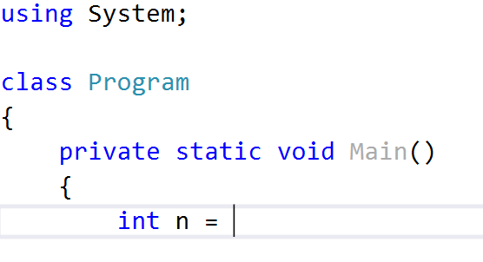

1. Then you should calculate the height of the towel. Which is the weight multiplied by 1.5.



Ok, but you should round it down to the nearest integer. Hint you may cast it to integer or use some round methods.

1. You can imagine the towel as a matrix or table with rows and each symbol as a cell of row. You can print row by row. So you’ll need some loops. One for rows and one for cells of each row.

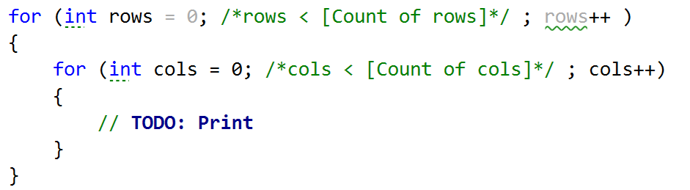

1. You should find when to print **‘.’** and when **‘#’**.Somehow you must find are you in right cell to print ‘#’.

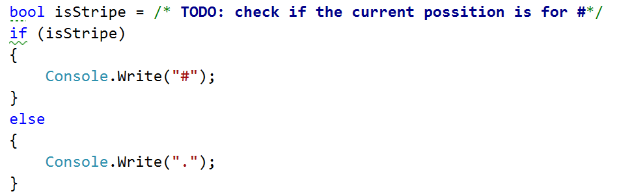

1. If you find the way to print the dots and stripes you’ll see that you should print a new line. Think about when you should print it.
2. Test the program with all examples.
3. Copy all the code and test it in Judge – <https://judge.softuni.bg/Contests/Practice/Index/104#2>